PART 3 --ASSIGNMENT 1

Create a web server using Python and render your name when user is connected

Create a folder on desktop with a filename app.py to create a python script

Install a package on command prompt using command----pip install flask

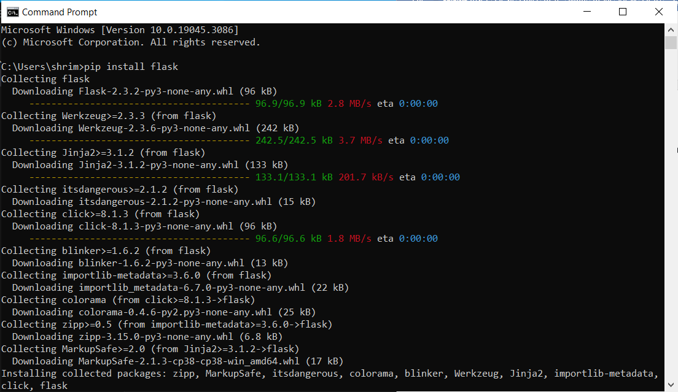

Writing a script to run the web server using flask

Syntax to run the server is ------app.run(host='0.0.0.0',port=5001,debug=True)

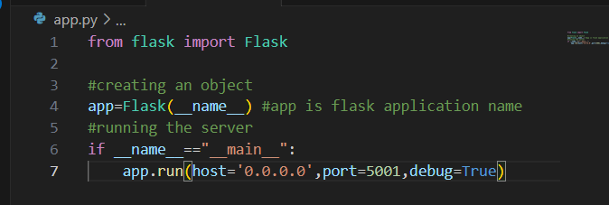

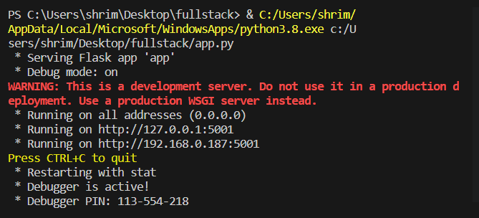

Render the name to users:

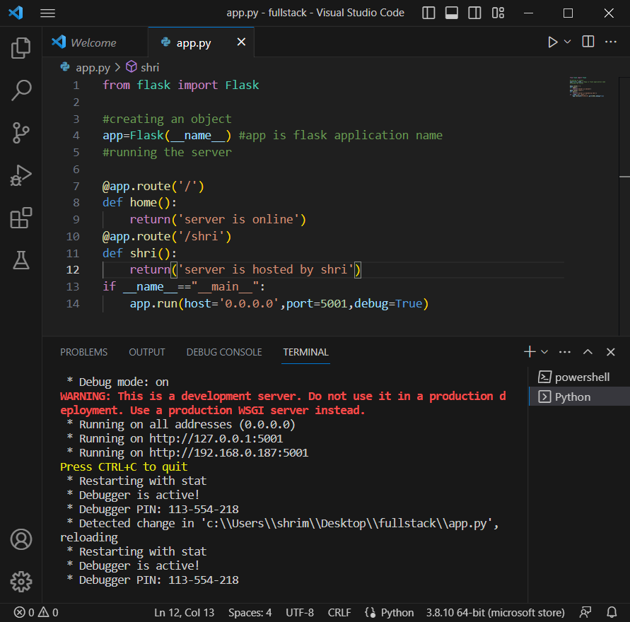

If we follow the link: <http://192.168.0.187:5001> we are redirected to home page

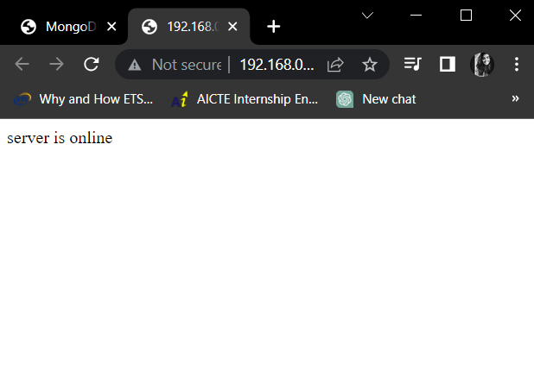

If we follow the link : <http://192.168.0.187:5001/shri> , we are redirected to this web page

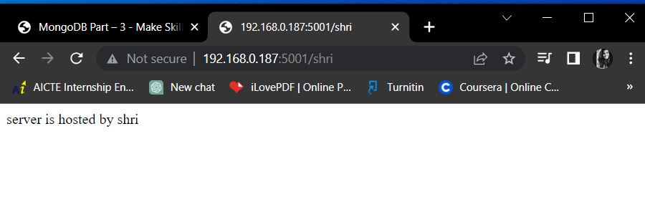

This is how we create a web server using python and render your name when a user is connected.